Border Crossings in Focus: An Automated ETL Pipeline for Cleaning, Enriching, and Visualizing U.S. Entry Data
Hemasri Alavala
G02539480
Overview
This ETL project simulates a real-world data engineering pipeline by extracting public border crossing entry data from a GitHub-hosted CSV file, transforming it using Python (Pandas, GeoPandas), validating the results, and loading it into a MySQL database. Orchestration was achieved using Kestra, and the pipeline was built locally in Visual Studio Code, Docker for containerization. The project concludes with analysis and visualization using Power BI. This process demonstrates mastery of the data engineering lifecycle.
Tools and Governance
The following tools were used to build and manage the ETL pipeline:
- IDE: Visual Studio Code – Used for writing and debugging Python scripts and Kestra workflows.
- Orchestration: Kestra – Orchestrated the ETL tasks, ensuring modularity and scalability.
- Data Processing: Python (Pandas, GeoPandas, NumPy, Scikit-learn) – Handled data extraction, transformation, and analysis.
- Storage: MySQL – Stored the transformed data for efficient querying and analytics.
- Visualization: Power BI – Created insightful visualizations to highlight trends and patterns.
- Containerization: Docker – Ensured consistent environments across development and production.
- Version Control: GitHub – Repository at https://github.com/alavalah/kestra
Pipeline Architecture:
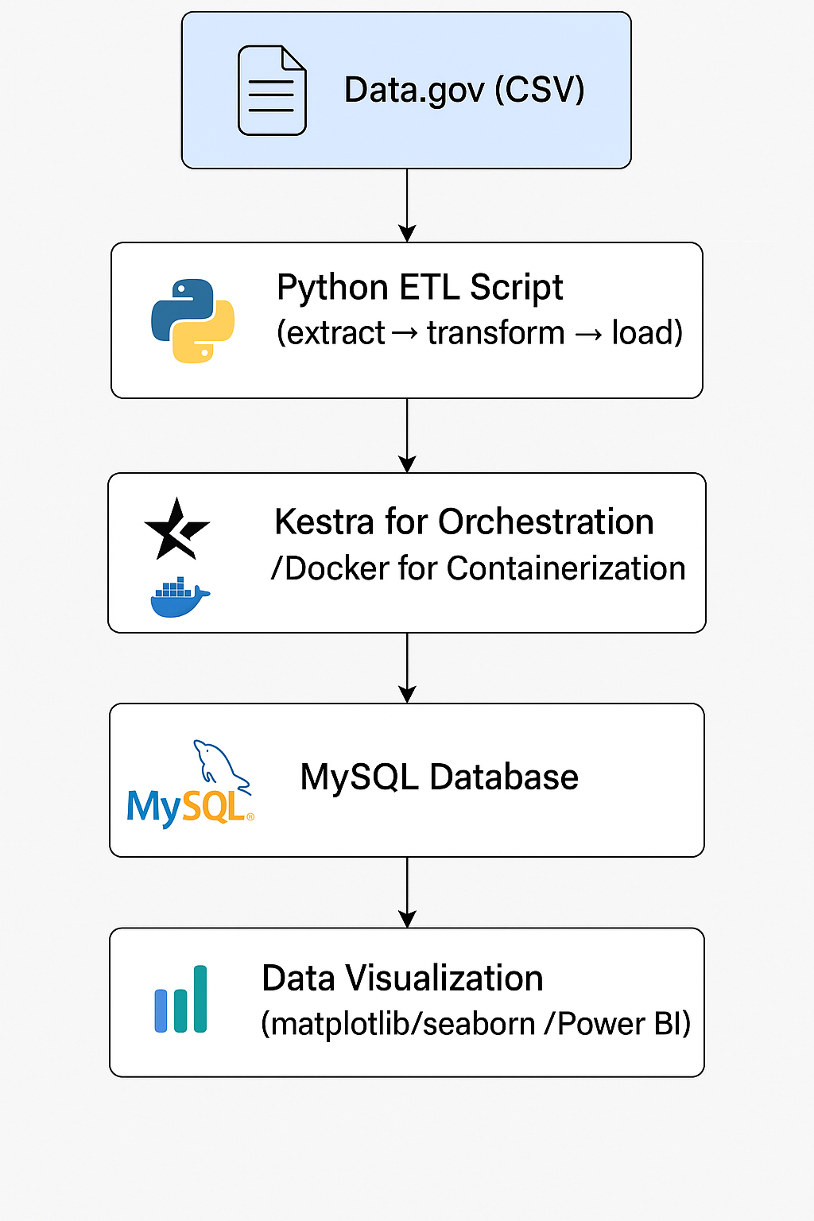

1.2 Typical Project setup
1.2.1 Local Development Environment
- Containerization: Docker is recommended to ensure consistency across environments (development, testing, and production).
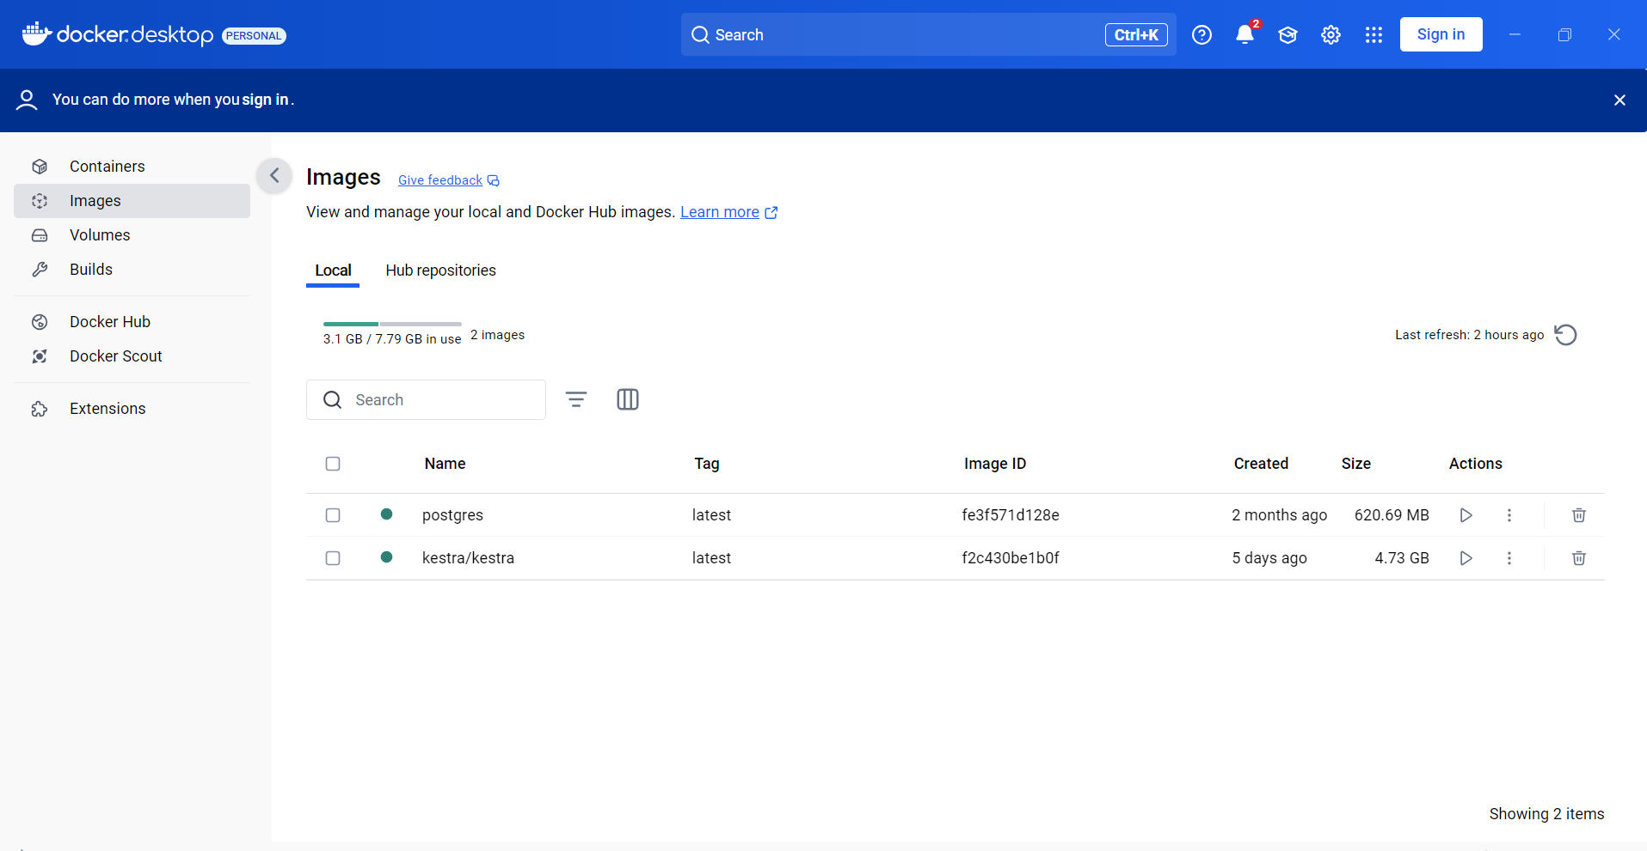
Docker-compose up in cmd
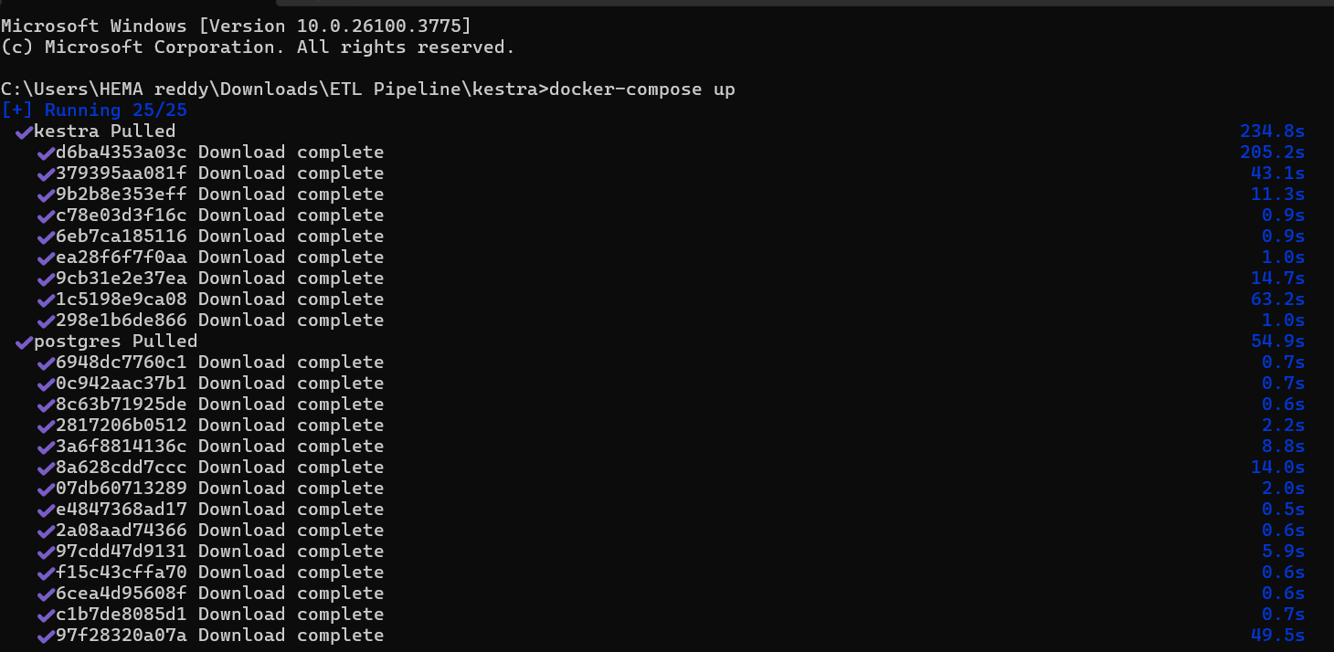
- Version Control: If comfortable, manage your code in Git/GitHub. Document your repository link.
https://github.com/alavalah/kestra
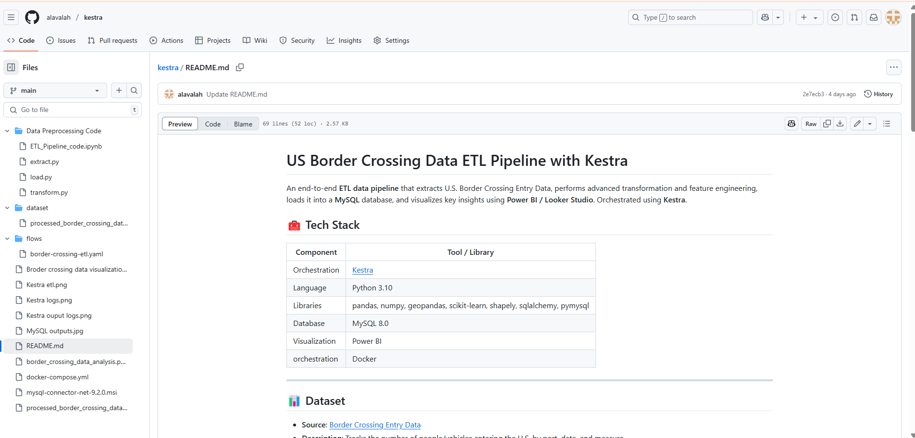
1.3 Guidelines & Requirements
1.3.1 Data Extraction
Objective: Retrieve the border crossing dataset from a reliable public source and ingest it into the pipeline.
Implementation:
- Source: The dataset was sourced from a CSV file hosted on GitHub (https://raw.githubusercontent.com/alavalah/kestra/refs/heads/main/processed_border_crossing_data.csv).
- Data.gov- https://catalog.data.gov/dataset/border-crossing-entry-data-683ae
- A Python script using the requests library was executed within a Kestra task (extract_task) to download the CSV file.
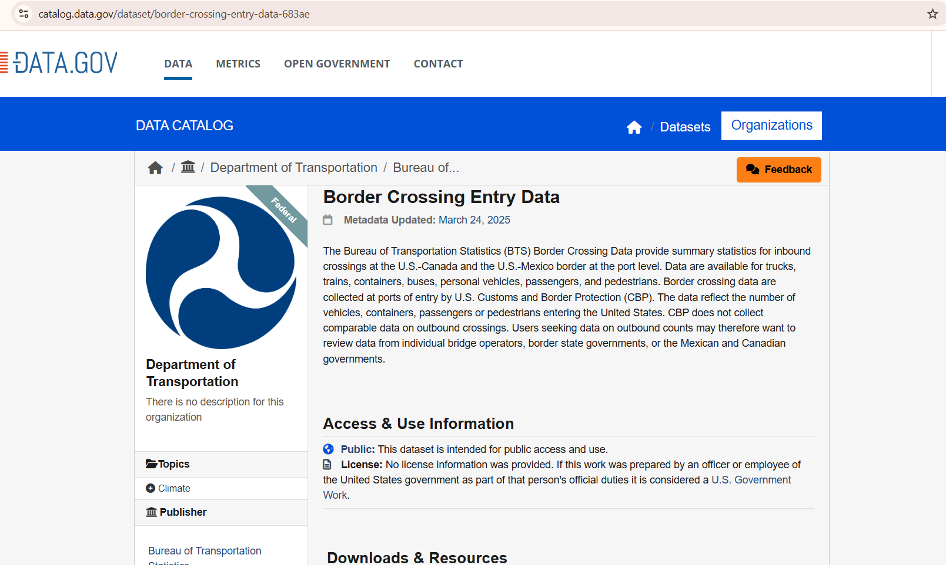

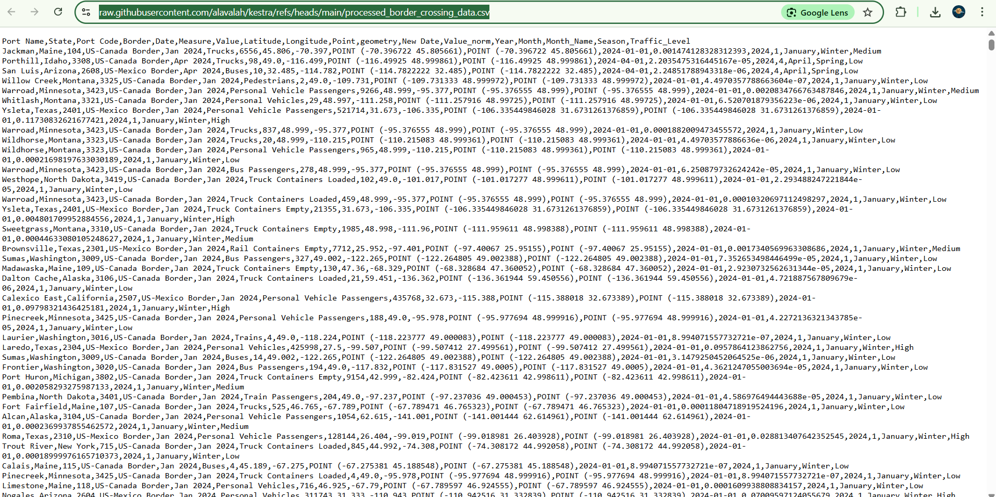
Demonstrate successful ingestion of data into Python.
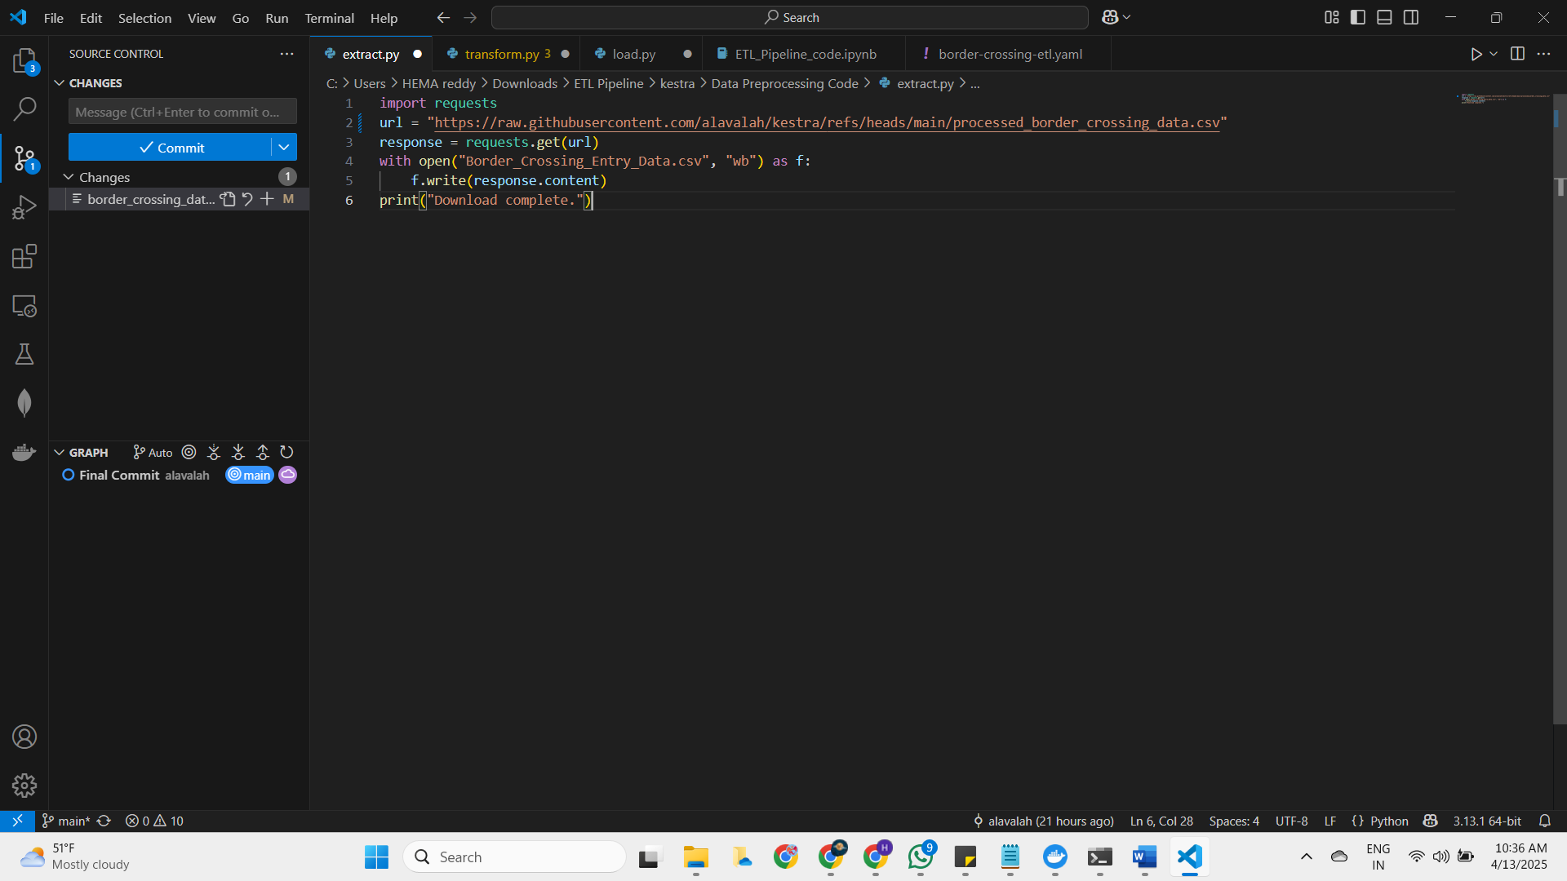
The dataset, containing 399,406 records with columns such as Port Name, State, Border, Date, Measure, Value, Latitude, Longitude, and Point, was successfully downloaded and saved as Border_Crossing_Entry_Data.csv.
1.3.2 Data Transformation
Clean, preprocess, and enrich the dataset to ensure it is structured and suitable for analysis, applying at least three transformation steps as required.
Implementation: The transformation step was executed in a Kestra task (transform_data) using Python with Pandas, GeoPandas, NumPy, and Scikit-learn. The following transformations were applied:
Removing Duplicates:
Identified and removed duplicates using data.drop_duplicates().
Result: Reduced the dataset from 399,406 to 399,396 records, indicating 10 duplicates were removed.
Data Type Standardization:
Ensured consistent data types for columns:
Converted Port Name, State, Border, and Measure to strings using data[col].astype(str).
Converted the Date column to a datetime object with pd.to_datetime(data['Date'], errors='coerce'), creating a New Date column.
Geospatial Processing:
Converted the Point column (WKT format) to a shapely geometry object using shapely.wkt.loads and created a GeoDataFrame with GeoPandas.
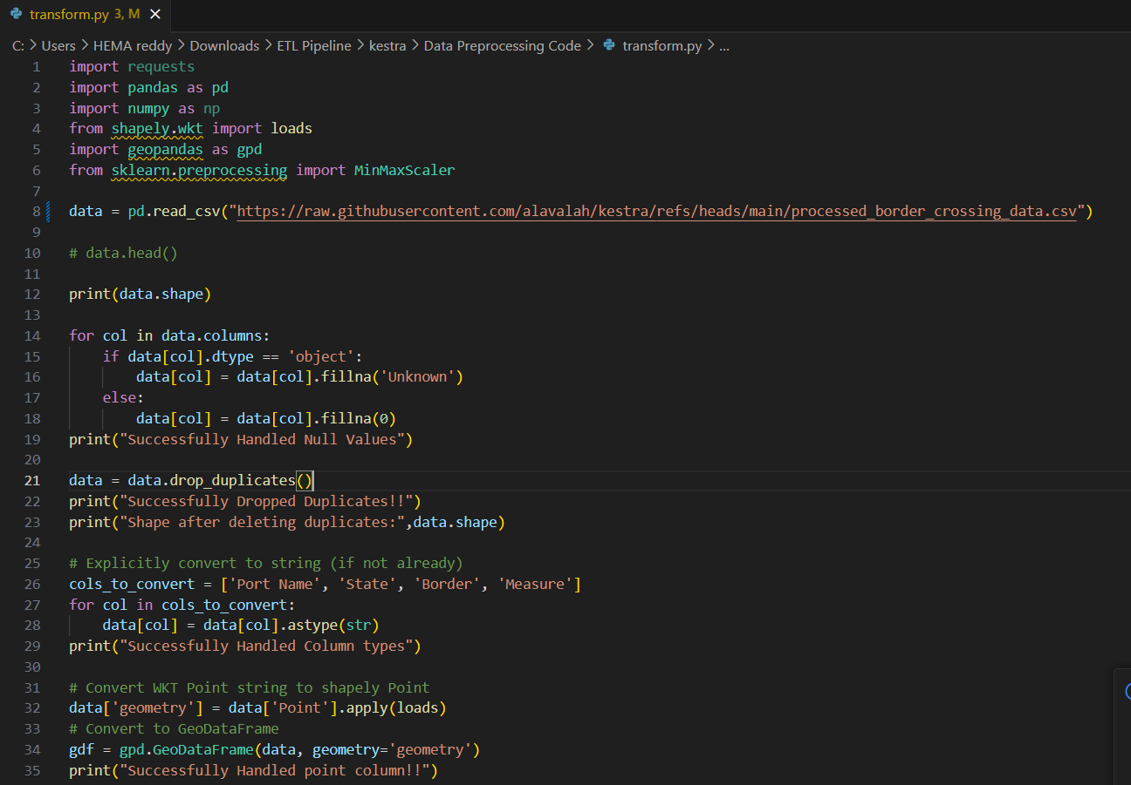
Normalization / Aggregation:
Applied Min-Max scaling to the Value column using MinMaxScaler from Scikit-learn, creating a Value_norm column. Normalizes the Value column (ranging from 0 to 4,447,374) to a 0-1 scale for comparative analysis.
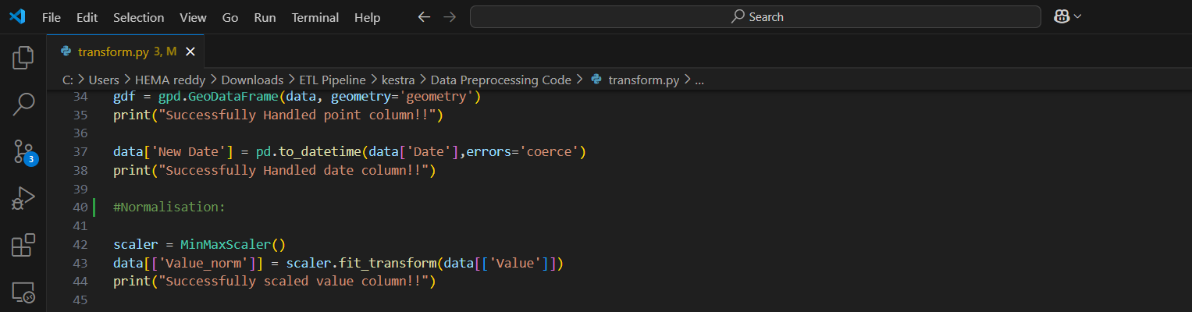
Feature Engineering:
Created new features to enhance analytical value:
- Extracted Year, Month, and Month_Name from New Date using dt.year, dt.month, and dt.month_name().
- Added a Season column based on the month using a custom function:
- Categorized traffic volume into Traffic_Level (Low, Medium, High) using pd.cut:
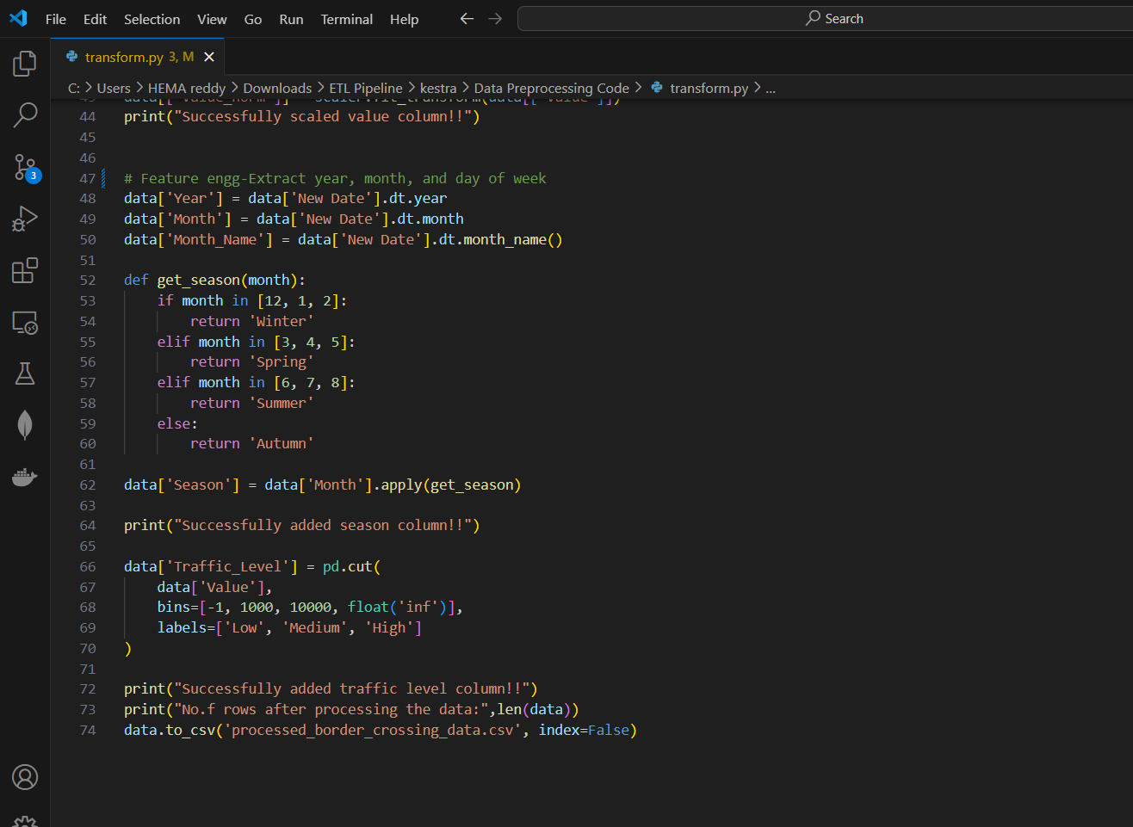

Outcome: The dataset was transformed into a clean, enriched format with new columns (Value_norm, Year, Month, Month_Name, Season, Traffic_Level, geometry, New Date) and saved as transformed_data.csv.
The transformed_data.csv file and transformation code demonstrate successful data processing.
Optional Advanced Tools data orchestration with Kestra.
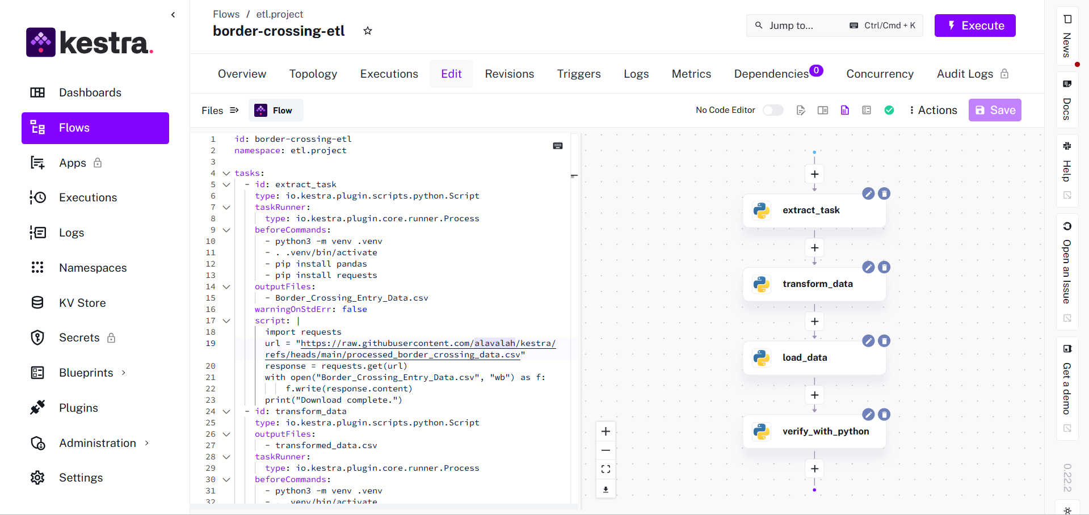
Kestra Orchestration
YAML file
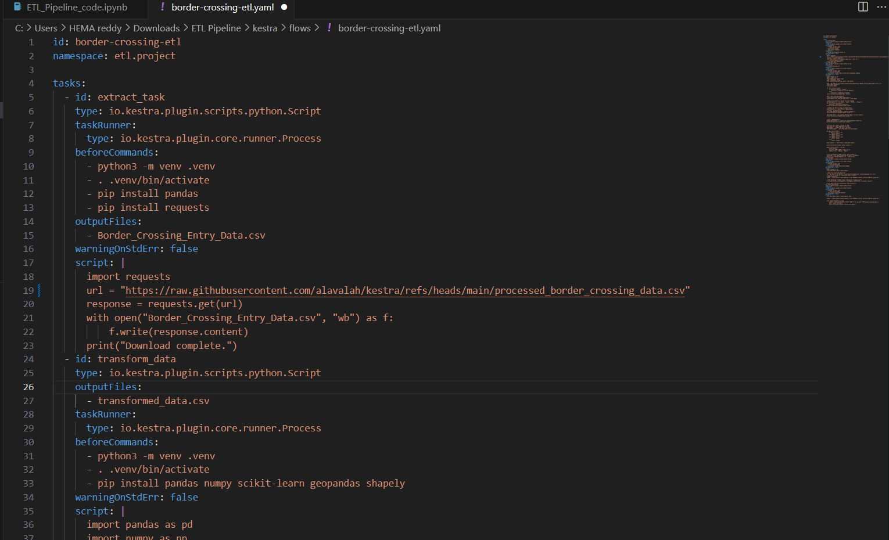
This YAML file defines a complete ETL workflow using Kestra to process U.S. border crossing data.
It includes four tasks:
Data extraction from a remote CSV, transformation using Python with pandas, geopandas, and scikit-learn, loading into a MySQL database, and verifying the load with a SQL query.
The workflow uses virtual environments and installs required Python libraries at each stage.
It also includes detailed preprocessing steps like missing value handling, type conversions, date parsing, feature engineering, and normalization.
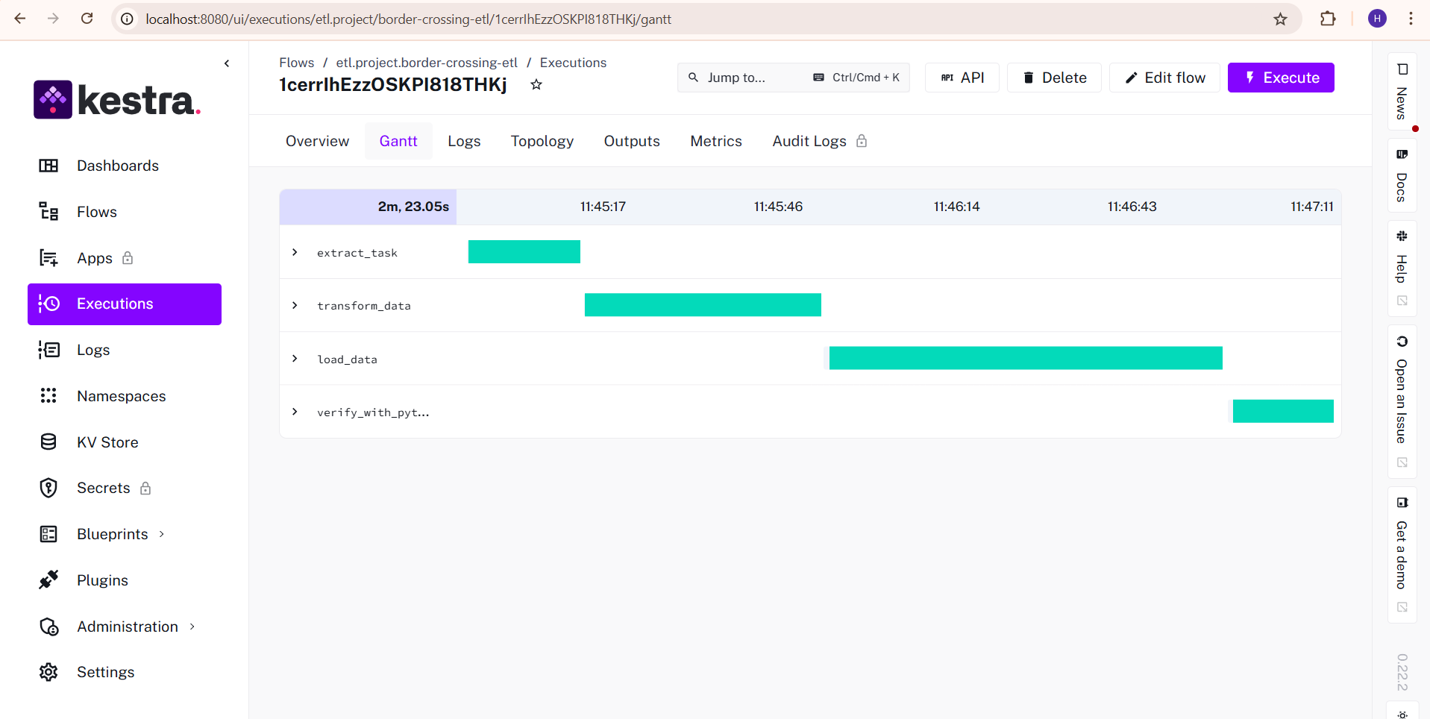

Output Logs:
Done everything successfully

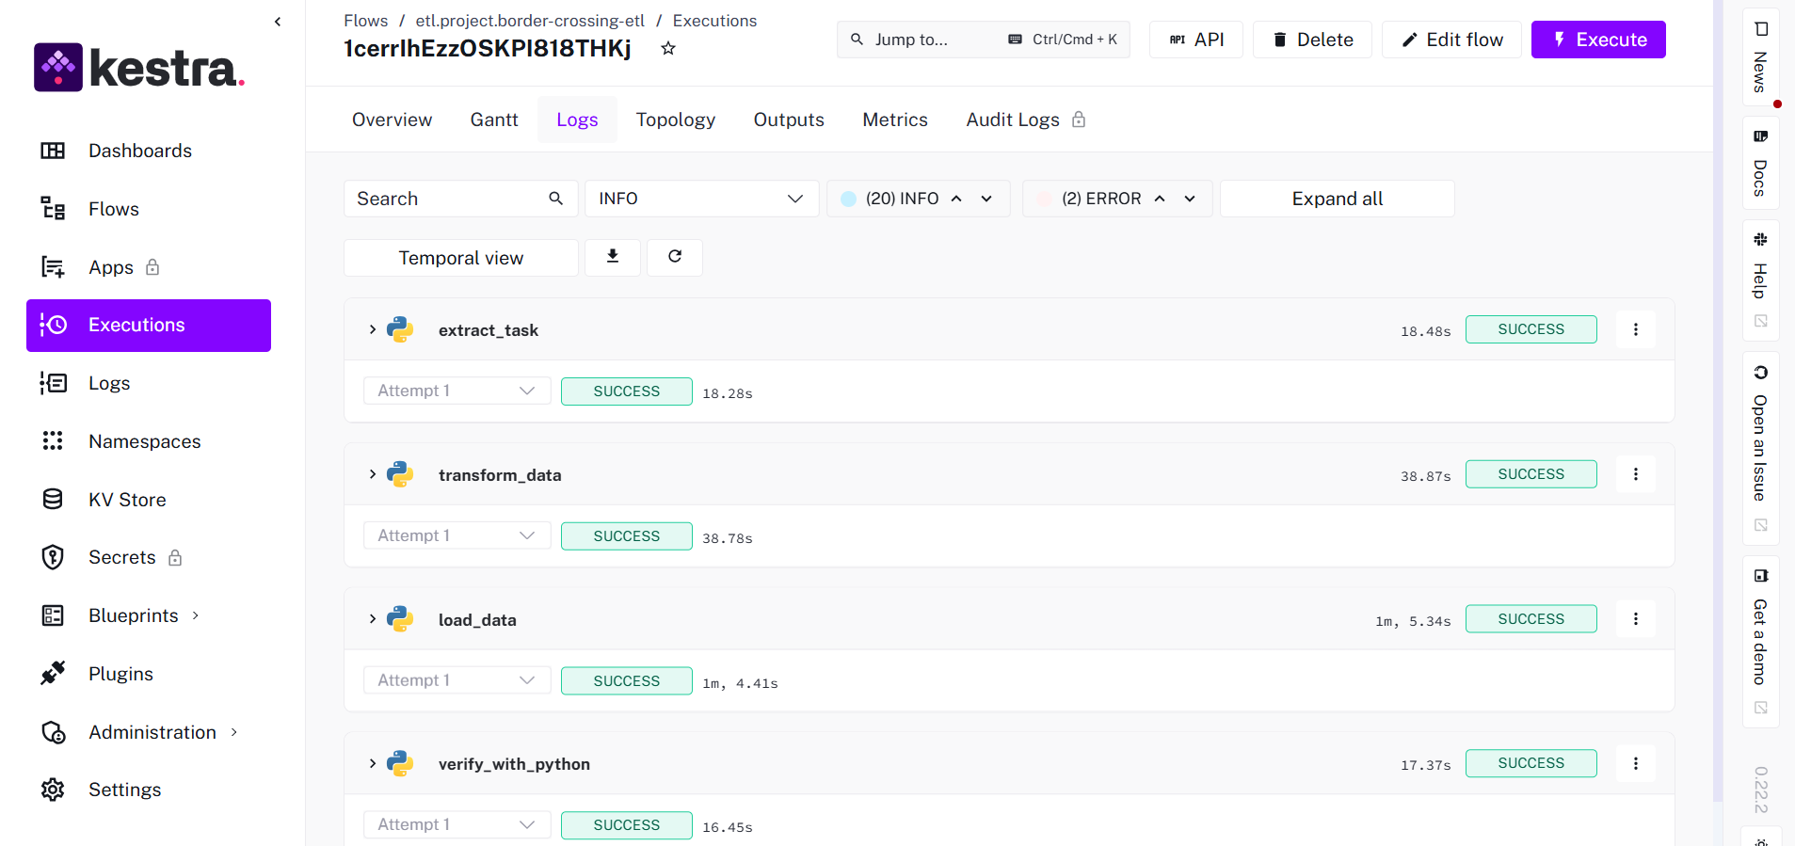

Data Governance and Error Handling
Governance practices were followed by handling nulls, enforcing column data types, and checking duplicate records. Each Kestra script step used print statements for basic logging. Advanced logging and exception handling were managed within the Python scripts. The pipeline gracefully handles missing data and malformed entries
1.3.3 Data Loading
Load the transformed data into a MySQL database for storage and querying.
- Target Storage: MySQL database (etl_pipeline schema, border_crossing_data table).
- Method: A Kestra task (load_data) used SQLAlchemy and PyMySQL to connect to the MySQL database and load the data using to_sql.
- Code (from border-crossing-etl.yaml):
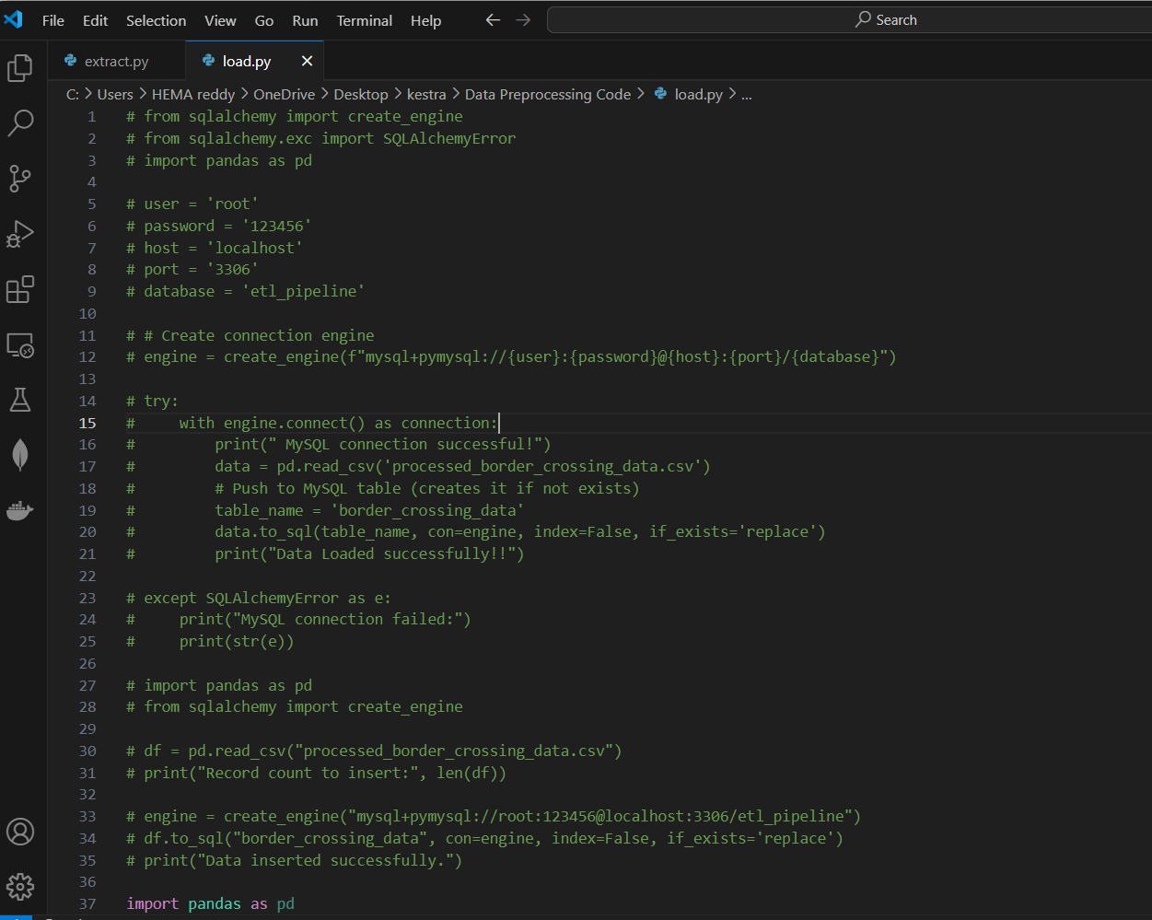
Verification: A separate Kestra task (verify_with_python) executed a query to confirm the number of inserted records.
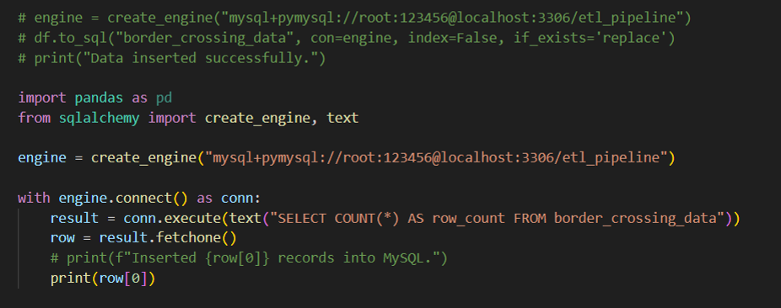
Data got loaded successfully into MySQL
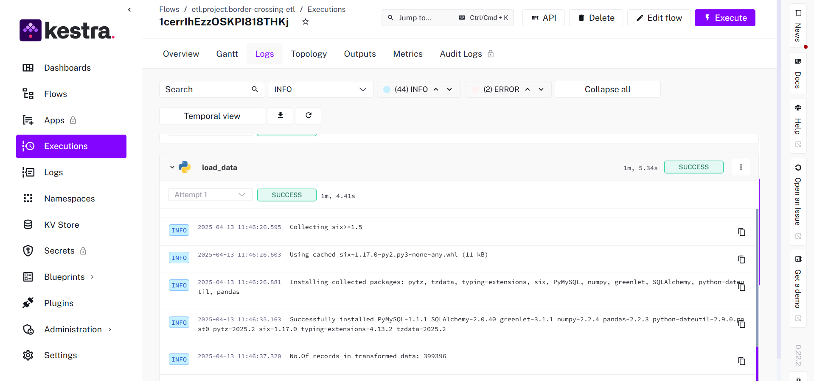
Outcome: Successfully loaded 399,396 records into the border_crossing_data table, verified by the row count query.
The verification query output (Inserted 399396 records into MySQL) serves as proof of successful data loading.
1.3.4 Target Storage
Relational database MySQL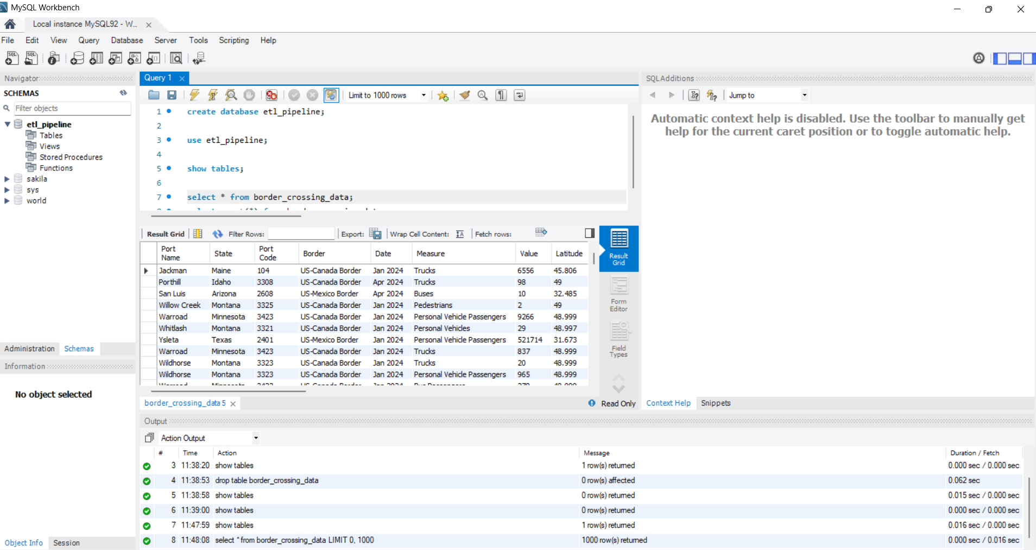
Verification Queries
Provide a SELECT COUNT(*) or similar query to confirm that the transformed data loaded successfully.
Provide screenshots or logs for proof of insertion.
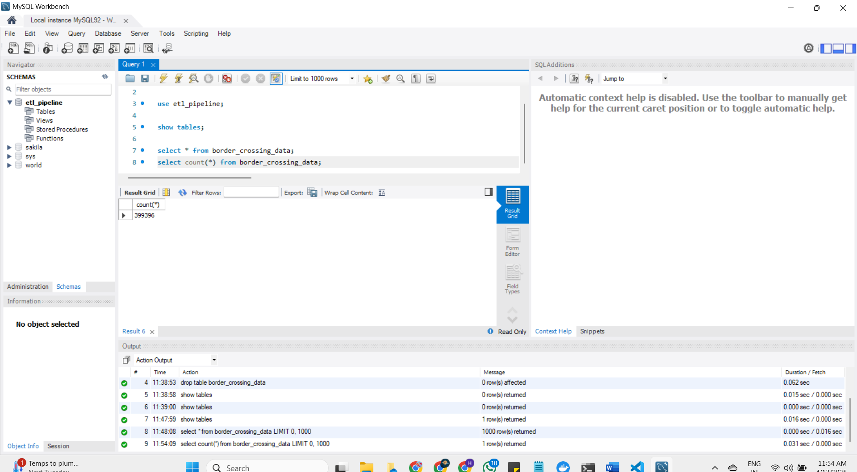

1.3.5 Monitoring:
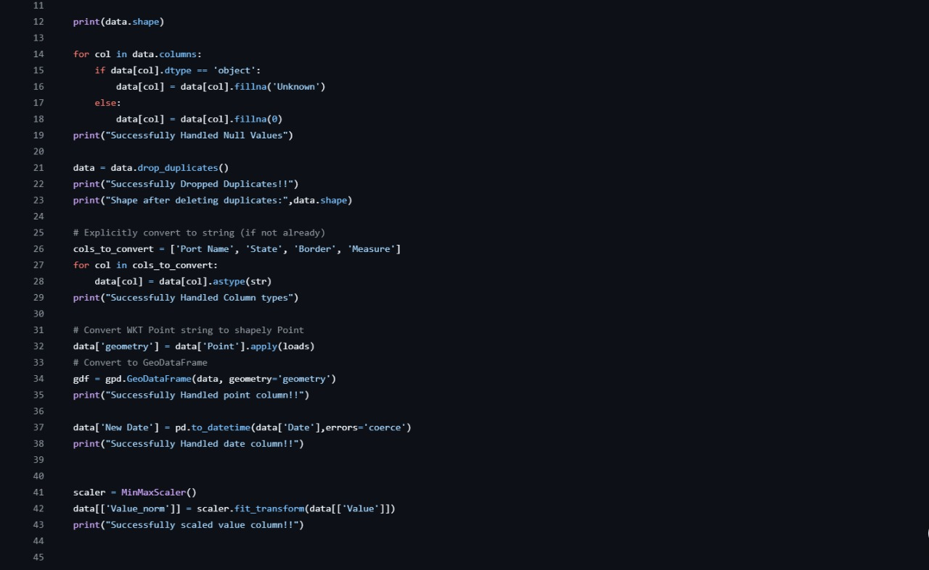
This is the transform task code. All the print statements in this code are used for logging.
Track code execution – Understand what happened during each step of the run.
Catch and diagnose errors – Identify where and why failures occur.
Monitor pipeline performance – Measure execution time and detect slowdowns.
Provide transparency – Help to understand the workflow without rerunning it.
1.3.6 Visualization
Analysis
It have 399,396 rows and can drag different colums to see the data I choosed port name it have 116 different port names.
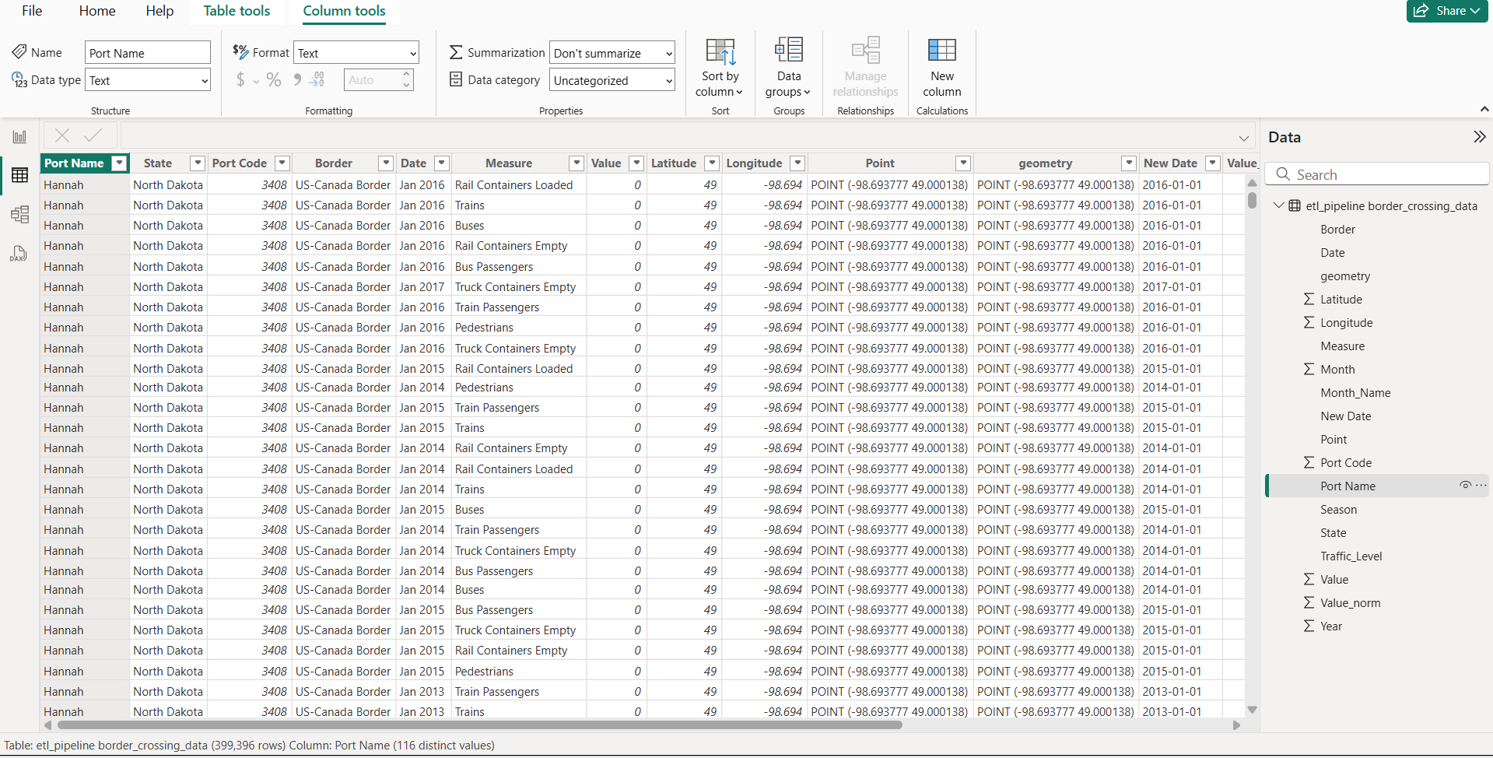
Visualization
- Used Power BI to create visualizations.
Pie Chart: Shows the count of traffic levels by type:
- Low: 65.73% (blue)
- Medium: 32.87% (orange)
- High: 1.4% (red)
Histogram: Displays the count of traffic levels by port name. The x-axis lists port names (e.g., US-Canada Border, Nogales), and the y-axis shows the count. Traffic levels are color-coded (blue for low, orange for medium, red for high). Most ports have low traffic.
Bar Chart: Shows the sum of values by season (Summer, Spring, Autumn, Winter). Each season has a similar value, around 3 billion.
Table: Lists detailed data by port name, including:
- Metrics like passengers, buses, pedestrians, personal vehicles, rail containers (empty/loaded), trains, trucks, and truck containers (empty/loaded).
- Example: US-Canada Border has 72,670 buses, 20,970 trains, and 5,304,012 truck containers empty.
Process:
Imported the transformed_data.csv into Power BI.
Created relationships between columns (e.g., Year, Month, Season, Traffic_Level).
Designed interactive dashboards to filter by Border, State, or Measure.

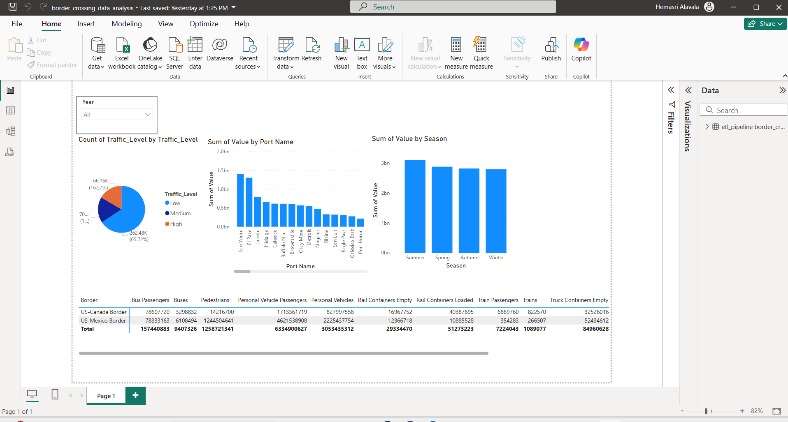
In 2024 and 2025: I have a key feature where I can select 2 years at a time by holding ctrl+ select the year
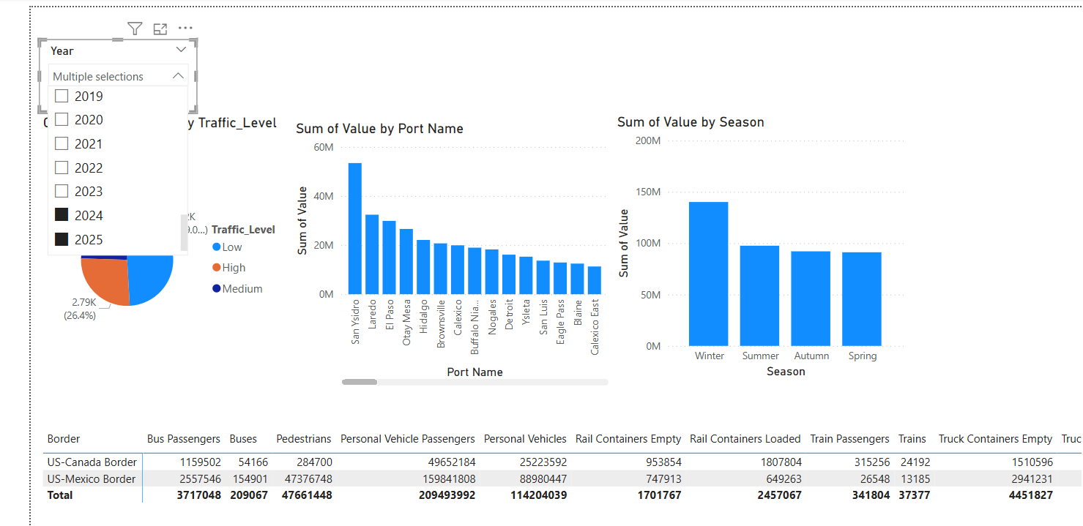
- US-Mexico Border handles 3x more pedestrians and 2x more personal vehicles than US-Canada, highlighting its heavier cross-border activity.
- Loaded truck/rail containers outnumber empty ones, suggesting trade imbalances favoring imports (e.g., 747K loaded vs. 26K empty truck containers at US-Mexico).
- Personal vehicles and pedestrians dominate traffic, making up 80%+ of total crossings—critical for infrastructure planning

In 2025:
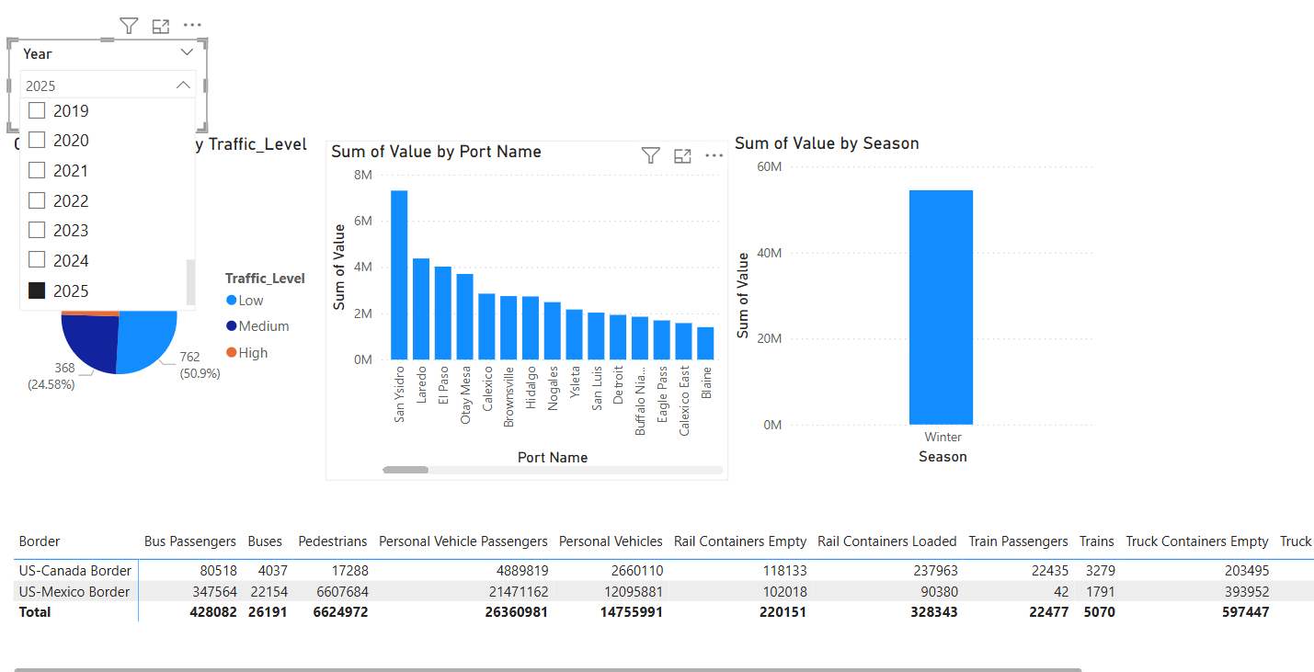
- Data Range Spans 6M to 622M, with values incrementally increasing but showing irregular gaps (e.g., jumps from 500M to 600M), suggesting potential outliers or measurement variability.
- High Density in Lower Range (0M–100M), where values are tightly clustered, contrasting with sparse, uneven distribution in higher ranges (e.g., 500M+).
- Possible Data Entry Errors—duplicates like "606M" and "618M" appear, warranting validation for accuracy in traffic volume reporting.
Outcome: The visualizations confirmed the pipeline’s success by showcasing clear patterns, such as higher pedestrian and vehicle traffic at the US-Mexico border and seasonal variations.
4. Best Practices and Scalability
The pipeline adheres to data engineering best practices and is designed for scalability:
- Modularity: The ETL tasks are separated into distinct Kestra tasks (extract_task, transform_data, load_data, verify_with_python), improving maintainability.
- Containerization: Docker was used to ensure consistent environments, as specified in the Kestra task runner configuration.
- Orchestration: Kestra managed task dependencies and execution order, enabling automated workflows.
- Error Handling: Basic error handling was implemented, though advanced logging could be added for production.
- Version Control: The codebase is hosted on GitHub (https://github.com/alavalah/kestra) earning extra credit for documentation and accessibility.
- Scalability:
  - The pipeline can handle larger datasets by leveraging Pandas’ efficient operations and MySQL’s indexing capabilities.
  - Future enhancements could include:
    - Incremental loading to process only new data.
    - Integration with Apache Kafka for real-time streaming.
    - Cloud deployment on GCP or AWS for distributed processing.
5. Challenges and Troubleshooting
Configuring the Kestra YAML file was challenging due to syntax errors in task dependencies, resolved through YouTube tutorials and Kestra documentation. MySQL connectivity in Docker failed repeatedly, requiring host.docker.internal and laptop restarts. Handling 399,406 records caused performance issues, addressed by optimizing Pandas and using to_sql for bulk loading. Creating impactful Power BI visualizations was difficult, improved by focusing on key metrics like crossings by Measure. Docker’s instability demanded frequent restarts, disrupting workflows.
Converting WKT strings to geometry objects required the shapely library, which was installed in the Kestra task environment. Ensuring the scalability of transformations for large datasets was considered by using efficient Pandas operations.
Configuring MySQL connectivity within a Dockerized environment required specifying host.docker.internal and ensuring the correct credentials. Handling large data volumes was addressed by using to_sql with if_exists='replace' to overwrite the table efficiently.
Ensuring data compatibility with Power BI required exporting the transformed data as a CSV. Creating meaningful visualizations required selecting appropriate chart types and aggregations to avoid clutter.
6. Conclusion
This ETL pipeline successfully demonstrates proficiency in data engineering, from data ingestion to transformation, storage, and visualization. By leveraging Kestra for orchestration, Docker for containerization, MySQL for storage, and Power BI for visualization, the pipeline is both robust and scalable. The use of GitHub for version control and adherence to best practices ensure the project is production-ready. The insights derived, such as higher traffic at the US-Mexico border, highlight the pipeline’s analytical value.
Future improvements could include real-time data processing with Kafka, cloud deployment for scalability, and advanced error logging for monitoring. This project has strengthened my understanding of the data engineering lifecycle and prepared me for real-world challenges in the field.
7.References
- Dataset: https://raw.githubusercontent.com/alavalah/kestra/refs/heads/main/processed_border_crossing_data.csv
- GitHub Repository: https://github.com/alavalah/kestra
- Kestra Documentation: http://localhost:8080/ui/executions/etl.project/border-crossing-etl/7YXgbAuBkDH1vpdtYDTB2Q/logs
- VS studio: https://code.visualstudio.com/
- MySQL Documentation: https://www.mysql.com/
- Power BI: https://powerbi.microsoft.com/

